Program 9
Create an HTML page to display a new image and text when the mouse comes over the existing content in the page using JavaScript Event Handling mechanism.

eventHandling3.html:
<html>
<head>
<title>program 10</title>
<style>
body {
text-align: center;
}
h1 {
font-size: 32px;
color: #2c3e50;
margin-top: 20px;
letter-spacing: 1px;
}
h2 {
font-size: 22px;
color: #34495e;
margin-bottom: 20px;
font-weight: normal;
}

#image {
position: relative;
width: 500px;
height: 300px;
margin: 0 auto;
}

#image img {
width: 80%;
height: auto;
}

#hidden {
position: absolute;
top: 0;
left: 0;
width: 100%;
height: 100%;
background-color: transparent
color: white;
text-align: center;
display: none;
}

#txt {
font-size: 22px;
font-weight: bold;
margin-top: 10px;
}
</style>
</head>
<body id="bc">
<h1>JAVASCRIPT EVENT HANDLING</h1><br>
<h2>Image and Text Change</h2>

<div id="image">
<img id="img" src="img1.png" alt="Image 1">
<div id="hidden">
<img src="img2.png" alt="Image 2">
</div>
</div>
<br><br>
<p id="txt">I see a car here !!</p>

<script>
var image = document.getElementById("img");
var hidden = document.getElementById("hidden");
var text = document.getElementById("txt");

image.addEventListener("mouseover", func1);
image.addEventListener("mouseout", func2);

function func1() {
hidden.style.display = 'block';
text.textContent = 'I see a bike here !!';
}

function func2() {
hidden.style.display = 'none';
text.textContent = 'I see a car here !!';
}
</script>
</body>
</html>

OUTPUT:
Before Event:
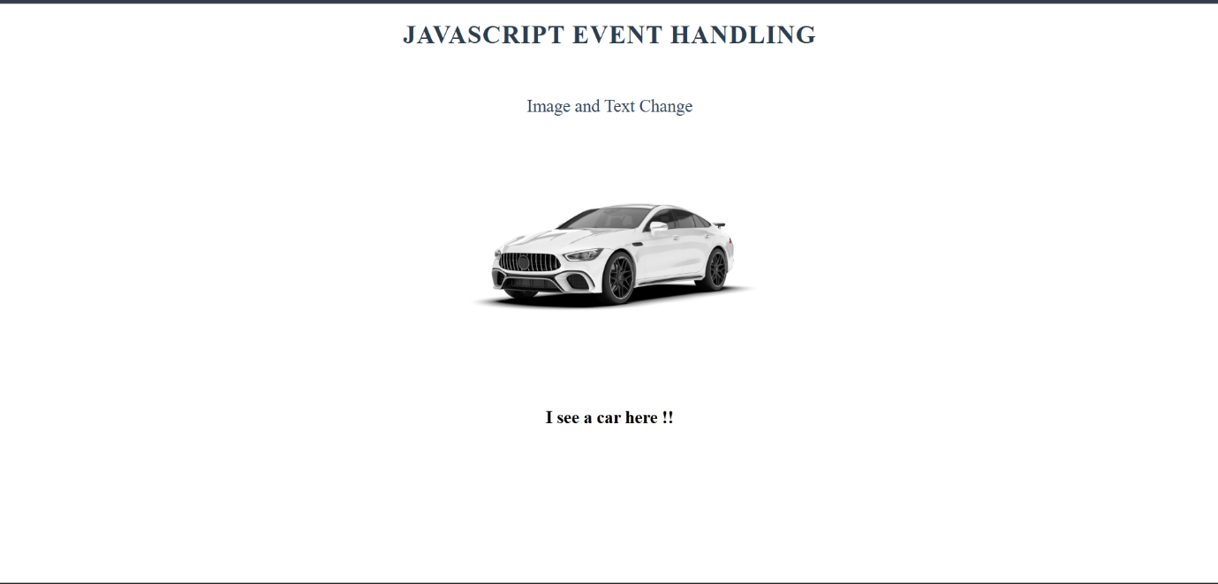

After event:
